Habiba Mohamed Wageeh (habibamohamedwageeh@gmail.com)


Graduation Project Proposal - Generative AI Track

Automated Educational Content Generation System

Project Description:
The Automated Educational Content Generation System aims to revolutionize how students and educators access and create study materials. This system will use generative AI models (such as GPT and GANs) to automatically generate educational content in the science domain, including explanations, summaries, quizzes, and flashcards.
Furthermore, there will be an optional feature where users upload lecture slides or notes, and the model summarily and automatically generates brief study materials.
The project will integrate cutting-edge NLP techniques (such as attention mechanisms and Transformer models) and MLOps practices for efficient model tracking, version control, and deployment. The output will be an end-to-end automated pipeline that is capable of performing content generation, enhancement, and deployment in real-time.
Group Members & Roles:
Name | Role
Salma Taha  Id: 21034477 | - Leads data collection and preprocessing  - Sources datasets from Kaggle, Hugging Face, etc.  - Applies NLP preprocessing using NLTK and SpaCy  - Documents data preparation and quality metrics
Rana Amr  Id :21034780 | - Fine-tunes Transformer models (GPT/BERT) for science content generation  - Evaluates model performance using BLEU, ROUGE, and Perplexity  - Assists with GAN integration and model comparison
Habiba Mohamed Wageeh  Id: 21084680 | - Coordinates team progress and milestone tracking Leads final report writing and presentation prep  - Implements GAN-based enhancements for content realism and coherence  - Supports evaluation using BLEU, ROUGE, and human scoring
Basmala Ahmed Atta  Id :21059767 | - Develops pipeline automation using Apache Airflow or Prefect  - Ensures workflow reliability and execution tracking  - Collaborates on MLOps integration and CI/CD setup
Ganna Mahmoud Zaghloul  Id: 21084706 | - Implements MLOps practices using MLflow  - Manages model versioning, experiment tracking, and retraining workflows  - Supports deployment on Google Colab and Streamlit
Ganna Eslam Yousry  Id :21084782 | - Builds optional module for summarizing uploaded lecture slides or notes  - Designs flashcard and quiz generation logic  - Conducts human evaluation and usability testing

Team Leader : Habiba
Project Objectives:
- Develop an AI-driven system that generates high-quality educational content (summaries, explanations, quizzes, and flashcards) in the science domain.
- Collect and preprocess large, trusted educational datasets (e.g., from Kaggle, Hugging Face, M3AV, and LPM datasets).
- Fine-tune Transformer-based models (GPT/BERT) for domain-specific text generation.
- Implement GANs to enhance the realism and coherence of generated content.
- Integrate an optional module to summarize user-uploaded lecture slides or documents.
- Develop a complete automated pipeline for preprocessing, training, inference, and evaluation.
- Apply MLOps practices for model versioning, experiment tracking, and cloud deployment (using MLflow and CI/CD).

Tools & Technologies:
Category | Tools / Frameworks
Programming Language | Python
NLP Models | Hugging Face Transformers (GPT-2, BERT), TextGAN (optional)
Deep Learning | TensorFlow
Preprocessing | Pandas, NLTK, SpaCy
Automation / Pipelines | Apache Airflow / Prefect
MLOps & Tracking | MLflow
Deployment | Streamlit
Version Control & CI/CD | GitHub
Cloud Platforms | Google Colab
Evaluation | BLEU, ROUGE, Perplexity, Human Score

Milestones & Deadlines:
Milestone | Deadline
1. Data Collection & Preprocessing | October 25, 2025
2. Model Selection, Fine-tuning & Training | November 10, 2025
3. GAN or Advanced Model Integration | November 20, 2025
4. Pipeline Automation | November 27, 2025
5. MLOps Integration & Deployment | December 3, 2025
6. Final Report, Demo & Presentation Prep | December 9, 2025
KPIs

KPI | Description | Measurement Criteria
1. Data Preparation Quality | Evaluate dataset completeness, cleanliness, and readiness. | Dataset coverage %, missing values ratio, preprocessing documentation quality.
2. Model Performance & Accuracy | Assess how well the model generates high-quality and coherent text. | BLEU, ROUGE, and Perplexity scores; human evaluation.
3. Pipeline Integration & Automation Level | Measure automation and reliability of the generative pipeline. | Workflow success rate, automation score, execution time.
4. MLOps & Deployment Readiness | Evaluate scalability, monitoring, and version tracking implementation. | MLflow tracking quality, model retraining time, CI/CD success rate.
5. Output Quality & Usability Score | Judge clarity, coherence, and usefulness of generated content (summaries, flashcards, quizzes). | Human evaluation survey (1–5), readability index.
6. Documentation & Presentation Quality | Assess clarity and completeness of all written and presented deliverables. | Report completeness %, presentation clarity, and demonstration quality.

Database Design
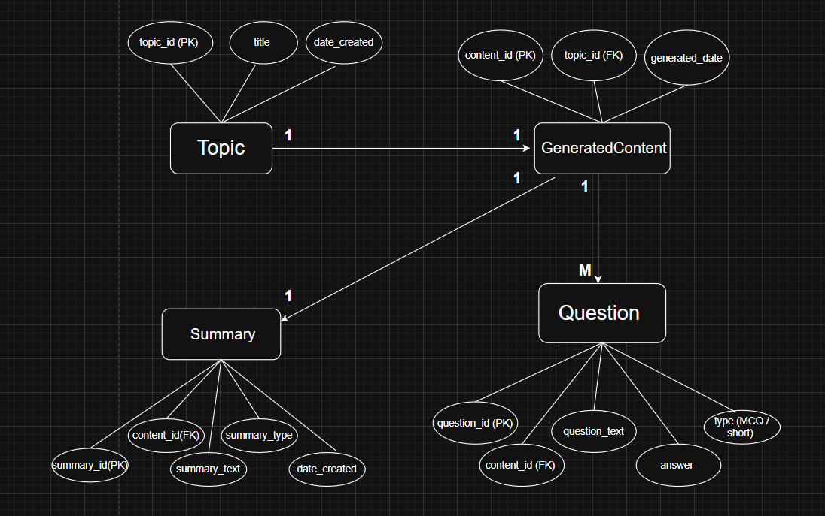

UI/UX Design


